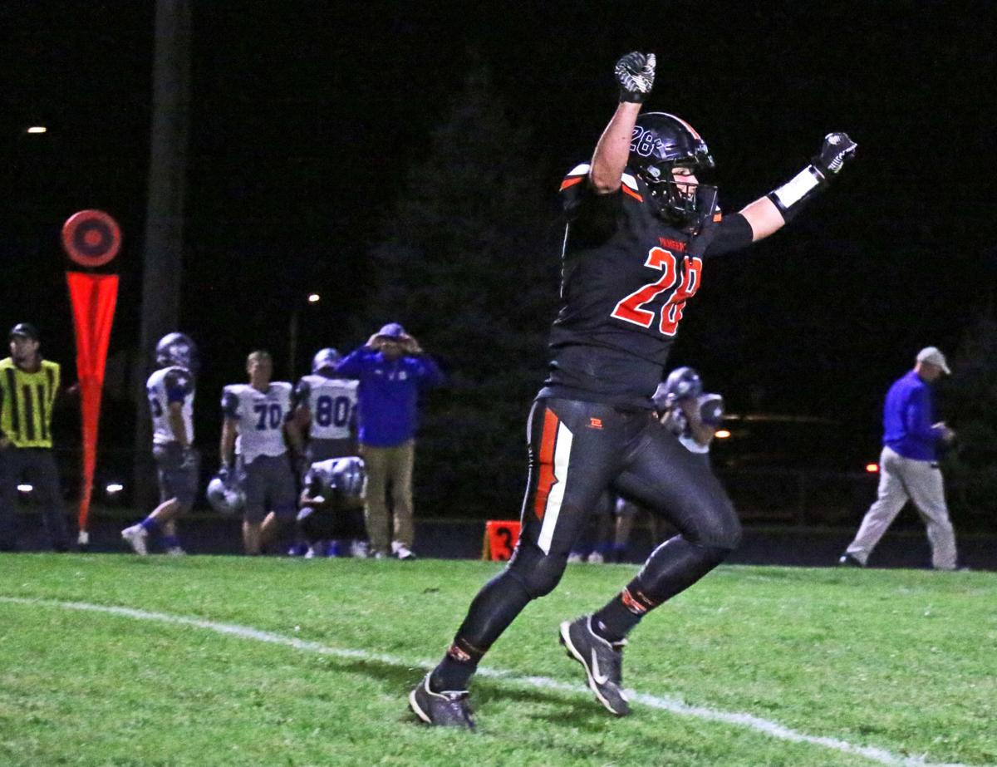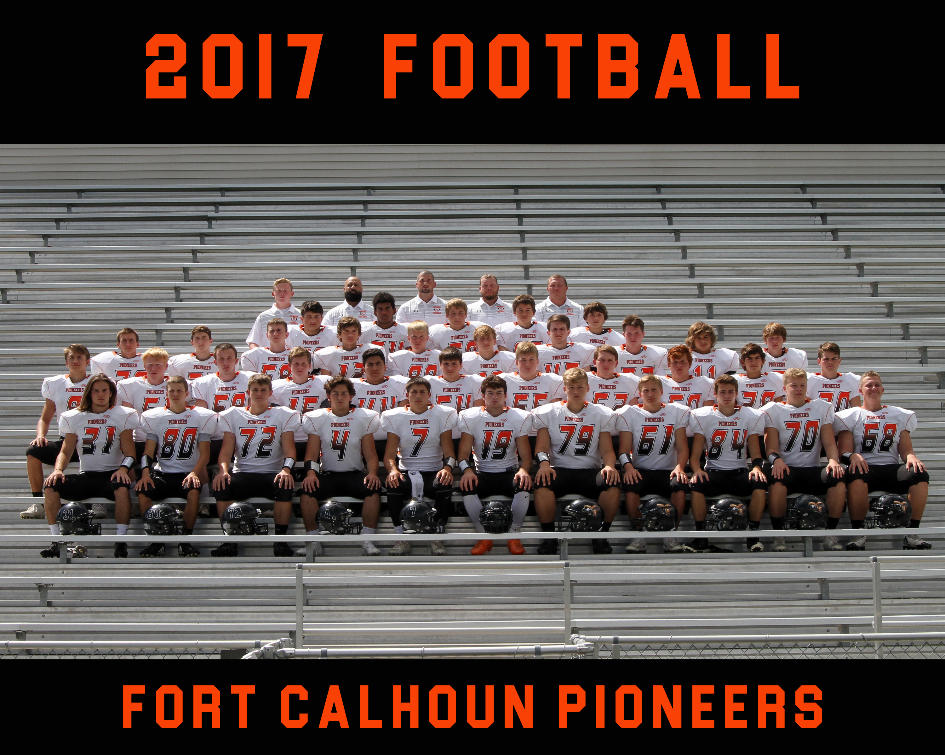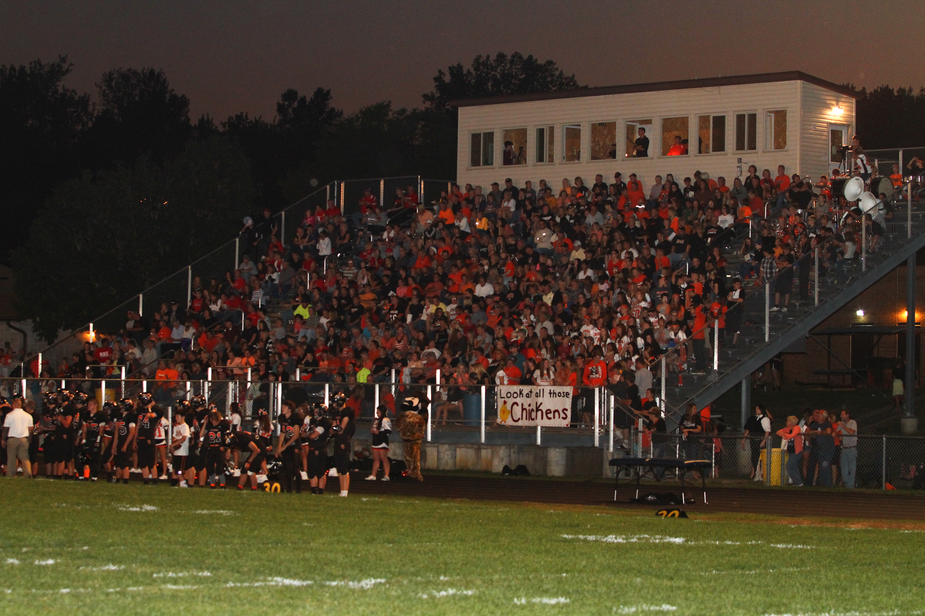

Fort Calhoun Pioneer Football

**“Leading the Way”**

We would love to host your team again as we celebrate Pioneer Football and the upcoming 2020 Season!

**$300 Per Team**

**4 Players**

**18 Holes of Golf**

**Dinner Social at RWGC**

**Pin Prizes**

**4 Drink Tickets**

**Raffle Baskets**

**Silent Auction**

**Raffle Basket Drawing at Approximately**

**7:00PM**

## Monday, July 20th

## 2 PM

## Check in Between

## 1-1:30 PM

### 21ST Annual

### Golf Tournament Fundraiser

**When:**

Monday, July 20th 2020

**Where:**

River Wilds Golf Club

* 3 Miles North of Blair, NE on Highway 75

## Fort Calhoun Pigskin 4-Person Scramble

# Pioneer Family!

# **Please Contact

# Coach Shepardson

# At 605-490-0402 if you would like to be a sponsor for our Golf Tourney Football Fundraiser. We appreciate all you do for Pioneer Football and look forward to 2020!

**Team Reservations**

Team Name: _______________________________

Contact Email: _____________________________

Player 1: ___________________________________

Player 2: ___________________________________

Player 3: ___________________________________

Player 4: ___________________________________

Please include check for $300 made payable to: **Fort Calhoun Gridiron Club**



Come

Show

Your

Support!

Go

Pioneers!!!

***Please Mail Entry to:***

Fort Calhoun High School

Attn: Adolph Shepardson, Head FB

-With check for $300 made payable to **Fort Calhoun Gridiron Club**

-Entry Deadline: Friday, July 17th

**Sponsorship Packages**

**Hole Sponsor: $100**

**Pin Prize Sponsor: $100**

**Tourney Sponsor: $400 & includes your team entry fee.**

Sponsorship Name: _________________________

Sponsorship Email: _________________________

Type of Sponsorship: ___________________________________

-Please include check for package amount payable to: **Fort Calhoun Gridiron Club**