Pioneer Cross Country
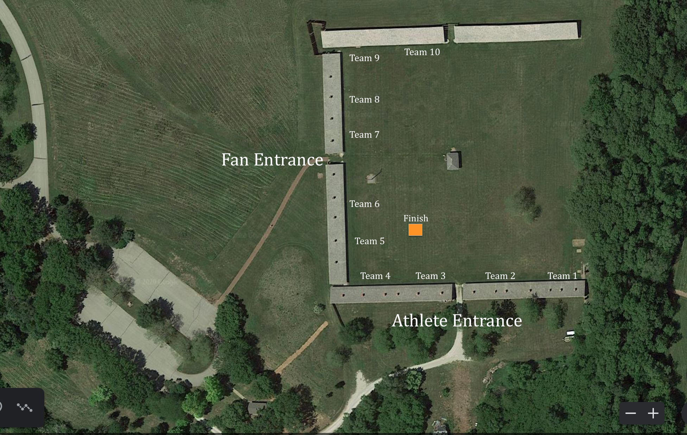

Meet Day Procedures:
- It is the goal at Fort Calhoun Community School events to keep communities and athletes separated. We will use social distancing (6ft apart). Communities and spectators should have limited to no contact with athletes and coaches during the competition. It is our focus to keep our coaches, athletes, and community members as safe as possible at our events.
- Signage
  - Signs will be posted with recommendations, guidelines, and procedures.
  - All schools and communities will be given Meet Guidelines one week in advance of the meet.
- Masks
  - Masks are required upon entry of the meet and entrance of Fort Atkinson Historical Park. Once spectators have entered and can properly social distance, masks are then optional.
- Gate Entry – Fort Atkinson protocol will be used
  - Fort Calhoun recommends a separate entrance for athletes/coaches and spectators.
- Coaches: Ask your parents and fans that are coming, to go to the Nebraska Games and Parks website and purchase a park entry permit prior to meet and print it to put in the car they are in. This will greatly speed up the process to enter the park.
  - Link: https://ngpc-home.ne.gov/ps/faces/index.xhtml;jsessionid=DF94B0CF7F0FD6B3AFD0105E08D9B756
- Coaches-Runners
  - Masks recommended while in camp
- Camps
  - Team Camps will be spread out as much as possible. We want all teams and athletes to have good distance between other programs. We recommend that teams stay in their designated area until warm ups and competition begin.
- Restrooms
  - Portable restrooms will be available for all athletes, coaches, and spectators.
  - 6 Portable Restrooms will be made available to accommodate coaches, athletes, and spectators.
  - Masks are required to use the portable restrooms

