Pioneer Football
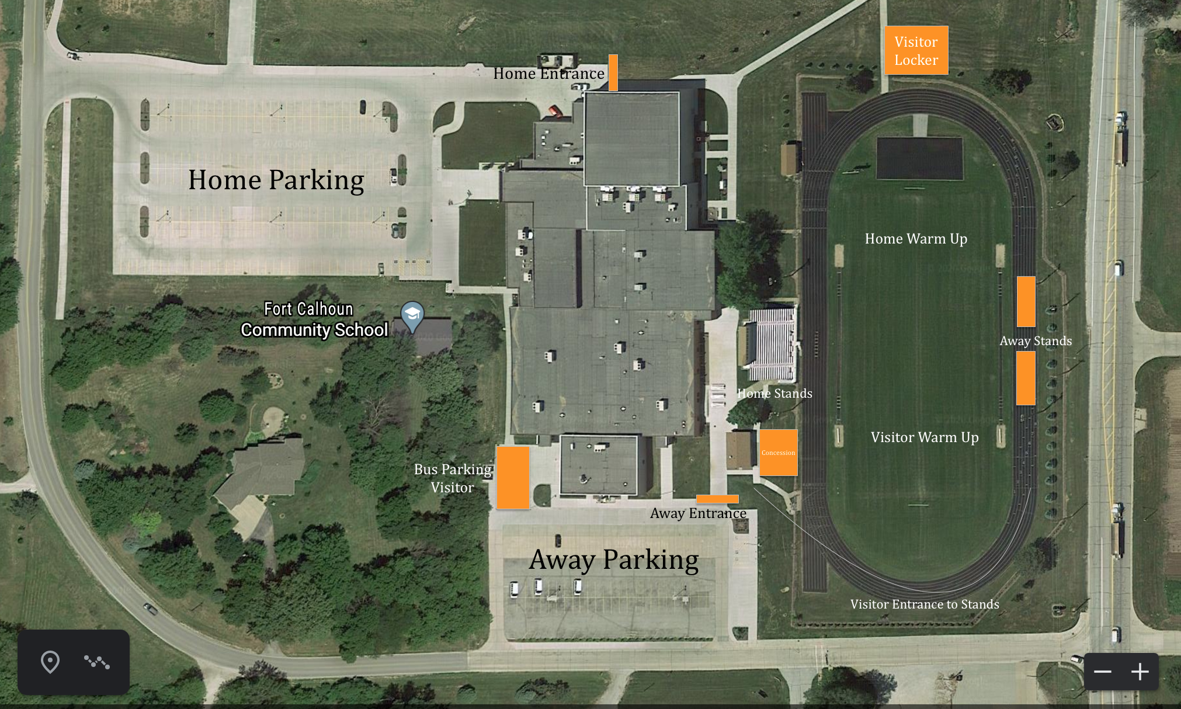

- Fort Calhoun Schools:
  - At Fort Calhoun Community Schools, it is our goal to keep communities and athletes separated at events. Please use social distancing. Communities and fans will have no contact with athletes and coaches during the competition. It is our focus to keep our athletes, coaches, and community members as safe as possible at our events.
- Entrance
  - Home Spectators- Northwest parking lot and north gate entrance.
  - Visitor Spectators- South parking lot and south gate entrance.
- Home and Away Stands
  - Visitor bleachers on the east side of the field will be provided to separate communities and promote social distancing.
  - Visiting spectators will walk along the south side of the track to get to bleachers on the east side of the field.
  - Bleachers will be caution taped every other row to promote social distancing.
- Masks
  - Required to enter the facilities and concession stand area
  - Once in the facility, masks are encouraged along with social distancing, but masks are no longer required.
  - Masks will be highly recommend in the stands
- Concession Stands
  - Mask required
  - A mask required area will be roped off. Once in the roped off area, masks will be required.
- Restrooms
  - Football Field Restrooms (Concessions area)
  - Masks required to use the restroom facilities
- Gate
  - Masks are mandatory

