Pioneer Softball

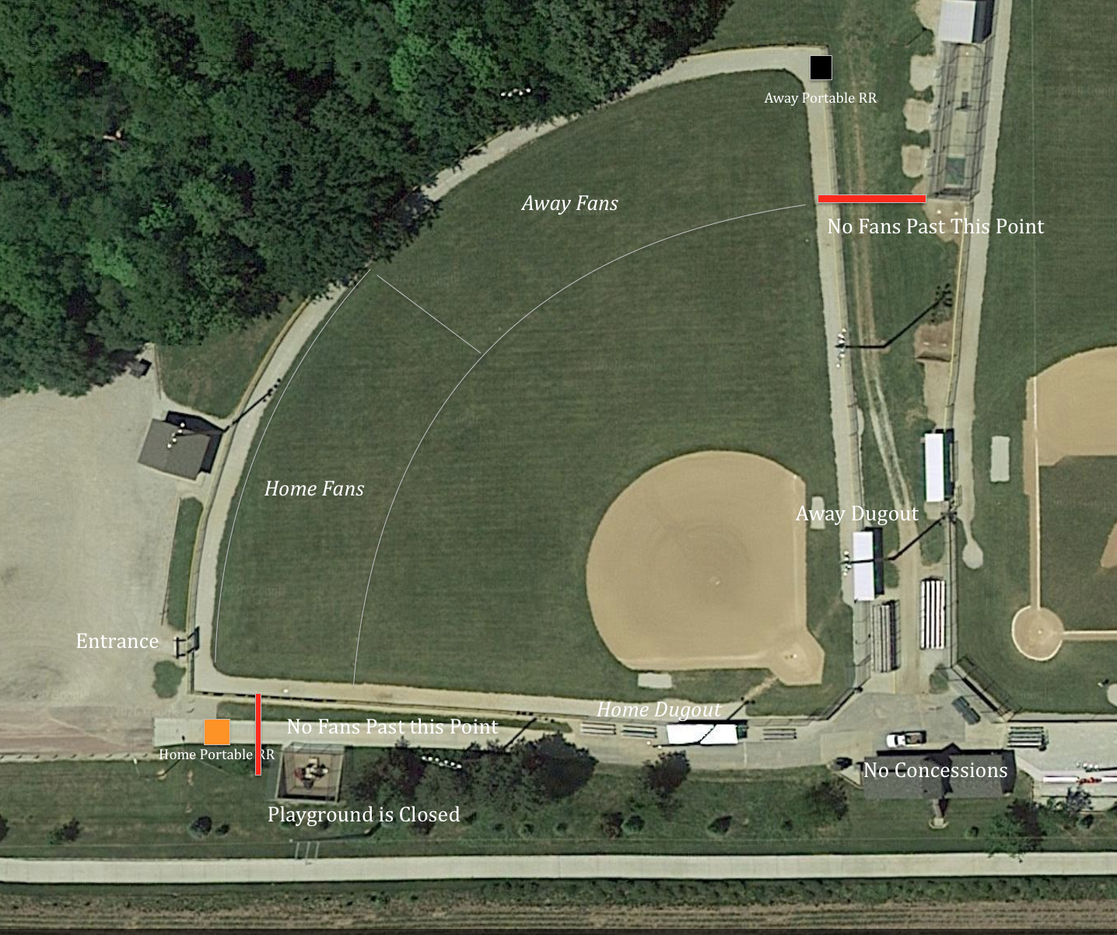

Game Day Procedures:
- It is the goal at Fort Calhoun Community School events to keep communities and athletes separated. Please use social distancing. Communities and fans will have no contact with athletes and coaches during the competition. It is our focus to keep our coaches, athletes, and community members as safe as possible at our events.
- Masks
  - Masks are required upon entry of the game. Once spectators are in their area and can socially distance, mask are then optional.
- Entrance and Seating
  - Both home and away spectators will enter through southwest gate entrance
  - Home spectators will occupy left to center field
  - Away spectators will occupy center to right field
    - Away Spectators- walk the warning track around left field to get to open seating area
  - Areas will be roped off
  - Please bring blankets, chairs, etc. for seating
    - Bleachers will not be provided
- Restrooms
  - Masks are required to use the Portable Restrooms.
  - A portable restroom will be used for home and away spectators
  - Home Fans- Portable is located in the southwest corner of the facility
  - Away Fans- Portable is located in the northeast corner of the facility
- Coaches and Athletes
  - Social distancing and masks are highly encouraged at anytime outside of competition.
  - Extended Dugouts
    - Home and Away dugouts have been extended to the bleachers. Players may use the bleachers before, during, and after the competition anytime social distancing cannot be achieved. No spectators will be able to occupy the bleachers. Bleachers are for athletes and coaches only.
  - Restrooms will be available to coaches and athletes in the press box. These restrooms are for athletes and coaches only.

