**Is your child living with depression, anxiety, ADHD or any other serious emotional disturbance and struggling in school and/or with life in general?**

Do **you** feel isolated and overwhelmed in trying to get your child’s needs met?

**No one understands this better than a parent who has been there themselves.** *Parent peer mentoring can help parents navigate systems more effectively, learn from the experiences of other families, feel less alone, and gain hope, ideas, and information.*

*Their families are living proof that things can and do get better!*

**Consider reaching out to work with a Parent Peer Mentor.**

**What can a parent expect from working with a Peer Mentor?**

All contact is by phone, text, or zoom. You and your mentor will decide what works best for you. You can work with a parent from your own school district or from another district if that is more comfortable.

• Someone to listen without judgement • Someone to care • Someone to encourage you

• Someone to help you problem solve • Someone to help you identify resources

**What qualifies a parent to be a Parent Peer Mentor?**

• Lived experience • Training • A willingness and commitment to give their time, energy and experience to help another parent improve outcomes for their child.

Meet the System of Care 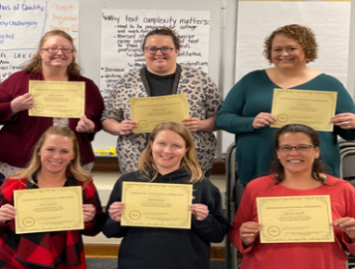 Parent Peer Mentors!

If you would like to learn more contact: **SOC Lead Family Coordinator**: Eve Bleyhl 402-680-8624 or [ebflcR6@gmail.com](mailto:ebflcR6@gmail.com) or ask your school counselor or therapist to send a referral for the SOC Parent Peer Mentoring Program. You can also access this link <https://go.unl.edu/mentoring-referral> or scan the QR Code  and self-refer**.**

This program is available at ***no cost*** to any parent who is supporting a child living with a mental or behavioral health diagnosis in Cass or Washington Counties in Nebraska.

**Parent Referral Form:** [**https://go.unl.edu/parent-referral**](https://go.unl.edu/parent-referral)