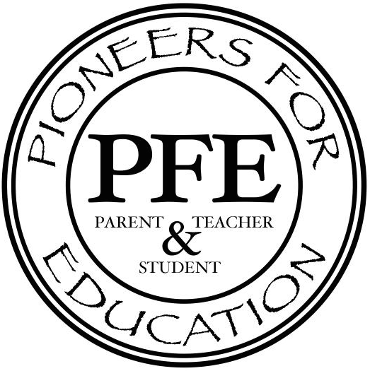 Family Game Night
Monday, January 18
6:00 – 8:00 p.m.
Have Fun and Raise Funds for Our School!!

Come play, have a good time and CR new ways of learning through participation in exciting, fast-paced, educational games. Fort Calhoun Elementary School is partnering up with CR Toys; a well-known toy store in Kearney, which specializes in educational games and toys for all levels, to host a Family Game Night.

You and your family are invited to attend Family Game Night Monday, January 18th. You will have tons fun and lots of laughs, all while learning to play several games, which teach skills and promote quick thinking. At the end of the evening, you will have the opportunity to order any of the games for your family and/or your child’s classroom. Each purchase will contribute money towards providing new games for your school. There is no charge to attend, so please come on out, have a blast and help your school! If you cannot attend and still want to help out your school, you can go to our website: www.shopcrtoys.com and enter the code: fc2016. Using the code will give your school credit and shipping will be free, since your purchase will be delivered to the school.

- Student Name: __________________________________ Grade: _______
- Total Number attending: _______

*Please return section above to your teacher by Tuesday, January 12.
For more information about CR Toys and their games go to shopcrtoys.com

